A Game with a Purpose
SCOUTING

What do these sports heroes have in common?

Hank Aaron-Baseball Hall of Fame

Bill Bradley-Basketball Hall of Fame

Willie Banks-Olympic Athlete

Chan Gailey-Professional Football Coach

Dennis Pitta-Baltimore Ravens’ Tight End
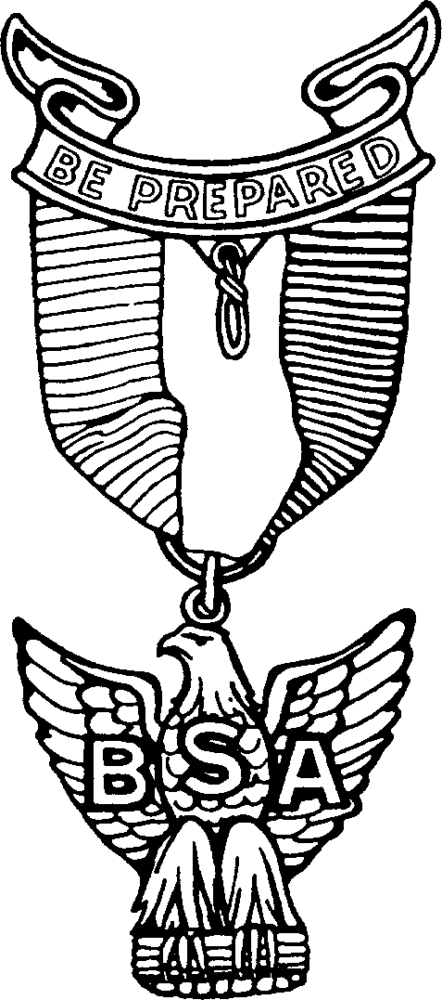

They Are
Eagle Scouts
Find your nearest unit
Beascout.org

