2024 Merit Badge University
January 6, 2024 & April 13, 2024
8AM-4PM
Chestnut Memorial UMC, Newport News, VA
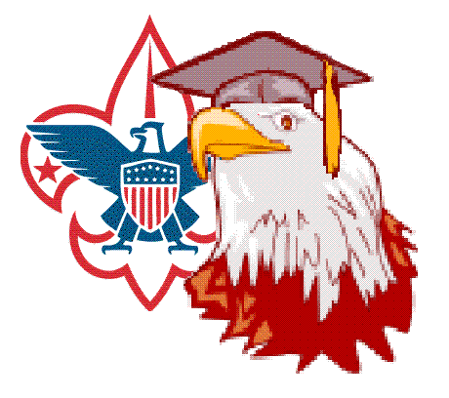

Hosted By:
Colonial Virginia Council
Boy Scouts of America

Registration Guide
Registration Deadline: December 30. 2023

I. General Description 2
A. Merit Badge University (MBU) 3
B. Location 3
C. Dates 4
D. Schedule 4
E. Abbreviations 4
II. Administration 4
A. Registration 4
1. Key Dates 4
2. Registration Fee 4
3. Maximum Capacity 5
4. Class Assignments 5
5. Attendance 5
6. How To Register 5
7. Late Registration 6
B. Requirements and Merit Badge Pamphlets 6
C. Blue Cards/Scoutbook 6
III. Program 6
A. Preparation 6
B. Homework 6
C. Field Trips 6
D. Partial Completion 7
IV. Conduct and Discipline 7
V. Uniforms 7
VI. Snacks and Lunch 7
VII. Health, Safety, and First Aid 7
VIII. Lost and Found 8

General Description

Merit Badge University (MBU)
The Colonial Virginia Merit Badge University (MBU) is an educational and advancement opportunity open to any active registered Scout BSA, Venturer, or Sea Scout. The event is hosted by the Colonial Virginia Council (CVC), Boy Scouts of America (BSA).

Questions by parents should first go to Scoutmaster/Unit Leader. Scoutmasters/Unit Leaders having questions should contact or email the event organizers below:

MBU Chairman  Bill Raftery  braftery@yahoo.com  757-645-5678 | or | MBU Co-Chairman  Laura Nelson-Rogers  lnelsonrogers32@yahoo.com  757-435-8989

Location
The location for MBU will be Chestnut Memorial UMC, 1024 Harpersville Rd. Newport News, VA, 23601 Please do not call Chestnut Memorial UMC.

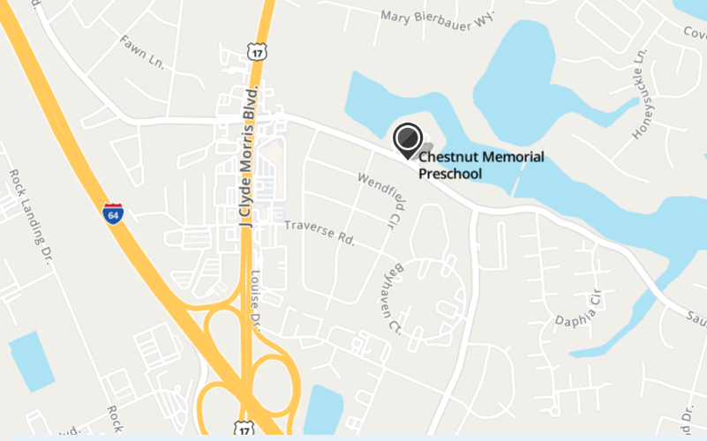

Dates

Session 1: January 6, 2024
Session 2: April 13, 2024

Schedule
The schedule for both days is the same.

8:00 AM | Church Doors Open, Report to your
8:45 AM | Opening Ceremony (Sanctuary)
9:00 AM | Classes Begin (Morning Period)
12:00 PM | Lunch Break, Stay in Session 1 Classroom
12:30 PM | Classes Begin (Afternoon Period)
3:30 PM | Classes End, All Scouts Depart
4:00 PM | Church Closed

Abbreviations
MB | Merit Badge
MBU | Merit Badge University
CVC | Colonial Virginia Council
BSA | Boy Scouts of America

Administration

Registration

Key Dates

December 30, 2023 | Registration ENDS. Registration may end early if the limit is reached.
January 6, 2024 | MBU Part I
April 13, 2024 | MBU Part II
April 27, 2024 | BlackPug is updated and reports are sent to Scoutmaster/Unit Leader and/or Scoutbook electronically updated. Summaries e-mailed to Scoutmaster/Unit Leader.

Registration Fee
The fee for attending MBU is $15.00 for each Scout.
The fee includes an event patch and a snack about midway through each class. Lunch is not provided and vending machines are not guaranteed. Scouts must bring their lunch, including drink.

Maximum Capacity
The limit for MBU this year is 200 scouts. If the limit is reached before the deadline, then registration will close and no more applications will be accepted by the Scout Shop. Most merit badge classes will be limited to 15 scouts, but some will be limited to as few as 8.

Class Assignments
Scouts are assigned to merit badges in accordance with availability on a first-come, first-serve basis.

Attendance
Merit Badge University is a 2-day event. Scouts are expected to attend both days. Due to the classroom format and the tight timetable, counselors will not repeat requirements missed when a Scout is absent either day. Requirements that are not completed at MBU will have to be finished by the Scout using a counselor outside of MBU.

How To Register

- Registration will be done by individual parents or guardians.
- Fill out application form online at https://scoutingevent.com/595-76835
- Select desired morning and afternoon merit badges.
- MBU registrar sends an email to Scout/Parent/Scoutmaster/Unit Leader confirming assignment.
- Parent (or Guardian) Permission
- By signing the application, a parent (or legal guardian) gives permission for the Scout to attend and participate in the Colonial Virginia Council Merit Badge University on both days.
- In case of emergency, every effort will be made to contact parents (or legal guardian). In the event they cannot be reached, the signature gives permission to a licensed physician or emergency first responder to secure proper treatment, including hospitalization, anesthesia, surgery, or injections of medication for the scout.
- By signing the application, the Scout’s parents (or legal guardian) agree to pick up the child at 3:45 PM each day. NO LATE PICK-UPS PLEASE!
- Emergency phone numbers given must be valid on January 6, 2024 to April 13, 2024.If a Scout requires help with medications that he needs to take while at MBU, please provide instructions on the application.
- The MBU Health and Safety Staff will not administer any treatments unless specified in the application and supplied by the Scout.
- Is a Scout has any other special needs, please provide instructions.

Late Registration
No late registration or on-site registration will be accepted.

Requirements and Merit Badge Pamphlets

MERIT BADGE PAMPHLETS ARE NOT AVAILABLE AT MBU
Those Scouts starting and completing any badges at MBU must use the requirements listed in the 2023 Requirements Book and requirements found at https://www.scouting.org/skills/merit-badges/all/

Blue Cards/Scoutbook
Blue Cards (Merit Badge Application, BSA Form #34124), are not required. An electronic printout from Scoutbook indicating that the initial unit leader meeting took place, or a letter from the Scoutmaster giving permission.

The blue card and/or Scoutbook must be filled out properly and signed by the scoutmaster/unit leader when the scout arrives for MBU. Counselors will not have time to make corrections.

Program

Preparation
Merit Badge University should not be considered another “school” where the pupils sit and stare for hours on end. Scouts should come prepared to participate in a seminar. The counselor’s job is to encourage self discovery and then test that each boy has the minimum knowledge and does the requirements. Each Scout should have read his merit badge pamphlet and prepared answers to each requirement. Scouts should be ready to take notes and come prepared with a notebook with blank paper and a pencil. Remember one goal of the merit badge advancement system is to develop individual growth and initiative.

Homework
Scouts are expected to do homework between January and April. The Scout is responsible for completing his requirements for the merit badge. Parents and Scout Leaders should remind the Scouts that they should take notes and pay attention to their homework assignments.

Field Trips
Occasionally, a counselor will set up to conduct a field trip to a local point of interest. Field trips are not scheduled during MBU, but may occur on some other date convenient to the counselor. If that occurs, a special permission slip will be provided, and parents will be responsible for furnishing transportation.

Partial Completion
If a Scout is unable to complete his merit badge, the “PARTIAL” completion will be noted on his Merit Badge Application, which will be returned to the Scout. MBU Counselors are seldom available to serve as counselor after MBU ends, unless arrangements are made afterwards which are acceptable to the Scout, his parents, and the counselor.

Conduct and Discipline
As a participant of the Merit Badge University, I will:
- Observe the Scout Oath (or Promise) and the Scout Law.
- Where my official uniform when requested.
- Attend the classes I am assigned.
- Be personally responsible for breakage, damage, or loss of property.
- Be courteous to other students, counselors, and staff.
- Clean up my classroom at the end of each session.
- Clean up my trash after eating a snack or lunch.

Uniforms
Scouts should wear the official field uniform for MBU. Most units call this a “class A” uniform. The uniform you normally wear to a troop meeting will be fine.

Snacks and Lunch
- Lunch is not provided and there are no provisions at MBU for food service or food preparation of any kind.
- Each scout must bring their own lunch including drink.
- All food must be consumed in the cafeteria. No food or drink is allowed to be consumed outside of the cafeteria.
- Counselors are permitted to drink in classrooms, but only covered containers should be used.
- Scouts are expected to clean up after themselves.
- A very light snack will be provided about halfway through each class.

Health, Safety, and First Aid
- Scouts should take their own medicine if needed during class.
- No running inside or outside the church
- No roller blades, roller shoes, roller skates, or skateboards are allowed.
- No alcohol, illegal drugs, fireworks, firearms, slingshots, or anything else that might distract from the learning environment. No tobacco or coffee for Scouts.
- The MBU First Aid station is at the Headquarters table.

Lost and Found
The MBU Lost and Found is located at the Headquarters table. The return of lost items after the end of MBU is not guaranteed, so be sure to check before you leave. Put your name on EVERYTHING: books, papers, lunch boxes, coats, hats – EVERYTHING.

